**Contents**

* + [1. Education](http://www.business-science-articles.com/articles/history/169-ghani-khan-pashto-poet#h1-education)
  + [2. Life in Jail](http://www.business-science-articles.com/articles/history/169-ghani-khan-pashto-poet#h2-life-in-jail)
  + [3. Ghani Khan's Poetry](http://www.business-science-articles.com/articles/history/169-ghani-khan-pashto-poet#h3-ghani-khan-s-poetry)
  + [4. Ghani Khan's love and affection for Pukhtoons](http://www.business-science-articles.com/articles/history/169-ghani-khan-pashto-poet#h4-ghani-khan-s-love-and-affection-for-pukhtoons)
  + [5. Ghani Khan's death](http://www.business-science-articles.com/articles/history/169-ghani-khan-pashto-poet#h5-ghani-khan-s-death)
    - [5.1. Ghani Khan Books](http://www.business-science-articles.com/articles/history/169-ghani-khan-pashto-poet#h5-1-ghani-khan-books)
  + [6. Related Articles](http://www.business-science-articles.com/articles/history/169-ghani-khan-pashto-poet#h6-related-articles)

[**Ghani Khan Pashto Poet & Philosopher**](http://www.business-science-articles.com/articles/history/169-ghani-khan-pashto-poet)

The great Pashto Poet **Ghani Khan** Was Born In (1914). Ghani khan was the best poet of the 20th century, in Pashto language. He was the poet of the time of many great poets like **Ameer Hamza Shinwari**,**Khushal Khan Khattak**,and **Rahman Baba** He was Very Well Known and respected artist and writer. Ghani Khan Made His Name Through Out The World But Still Most of the people know little about Ghani Khan. most of the people's views about ghani khan are" a poet who wrote about love,music,leasure,wine and sensuality" some people says Ghani Khan is a rebel. While some says he is a heretic,

**Khan Abdul Ghaffar Khan** was the father and **Khan Abdul Wali Khan** was older brother of **The Great Ghani Khan**.

## 1. Education

Ghani khan recieved his early education from a teacher in a mosque.Ghani Khan studied at the Rabindranath Tagore's Shanti Niketan Art Academy. During his studies he starts taking interest in painting and sculpture. He studied sugar technolog in America and after returning home he started working at a sugar mill in Takht Bhai in 1933. Due to his father influence he was also involved in politics not that much active like his father. He was a staunch supporter of the cause of Pathans.

## 2. Life in Jail

In 1948, Ghani Khan was arrested by the Government of Pakistan. But he gave up politics by then. He was imprisoned for six years in different jails across the country. During his imprisonment he wrote a collection of poems **"Da panjray Chaghaar"**. He declared it as the best work of his life. In 1958 he published a short book in prose, **"The Pathans"**. Besides his poetic genius, Ghani khan possesed a profound knowledge about his native and foreign cultures.

## 3. Ghani Khan's Poetry

Writings of Ghani khan Reflects the various phases of his life.As most people dont know about Ghani khan's personal life. Many people know him as a poet, who wrote about love and affection, music and lore, sensuality and liquor. while others know him as a rebel.Bacha khan was a staunch supporter of non-violence and so was his son Ghani khan.He believed in struggle and hardwork. In December 1945, Ghani khan then 32 years young and energetic was elected as the youngest member of the central legislative assembly of India. After spending six years in jail, he devoted the rest of his life to poetry. His son named Fareedon khan was killed by a peasant in 1987.This incident broke his heart but the Great Ghani Khan pardoned his son's killer. The death of his son, the poor and miserable condition of pathans, and atrocities by the government gave his poetry a profound philosohipcal color which became an insignia of his literary persona.The following poem depicts hatred against the west and portrays the miserable condition of Pashtoons

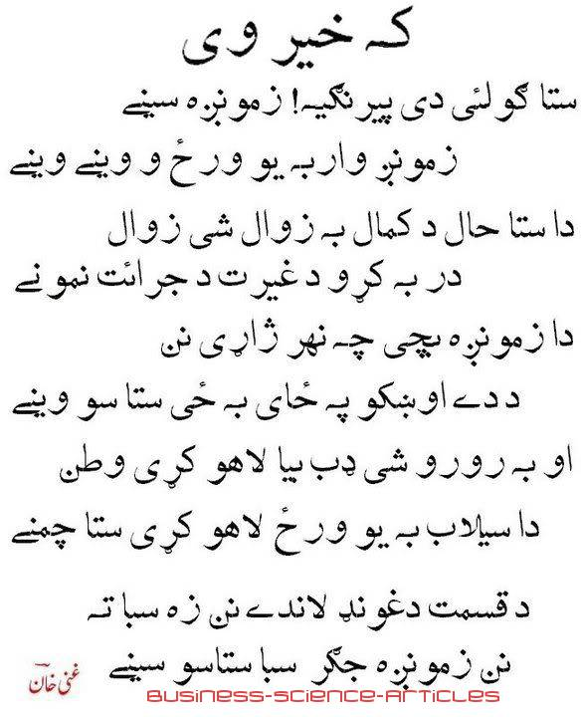

This is due to his diverse and unique personality that one can see the many different shades in his poetry.According to Ghani khan, "it is the duty of the poets to turn man's attention to those higher centres of his being where he might see the reflection of his own perfection and the face of his eternal beloved-- beauty. A poet, therefore must worship beauty-- in thought, in word and in deed." for Ghani khan Love was the divine gift of God.

**Many singer sung his ghazals and Rubayee including renowned pashto singers** like Sardar Ali Takkar, Khial Muhammad, Gulzar Alam and many more.But one thing remans as a fact that his poetry is difficult to sing, but great singers like Sardar Ali Takkar have done the job very skillfully and gained praise throughout the world.

## 4. Ghani Khan's love and affection for Pukhtoons

His literary works were not confined to a single language (pashto), In 1947 his first English book, The pathans was published.It was a descriptiopn of the history, culture norms and values of Pakhtoons. This book also portrays their feuds, enmities and their attitudes towards life."Pathan is not merely a race but in fact, a state of mind; there is a Pathan lying inside every man, who at times wakes up and overpowers him," he once wrote. He was very proud of himself being a pakhtoon. And he thanked God that he was born among Pakhjtoons.

## 5. Ghani Khan's death

Ghani khan died on March 15, 1996 in peshawar.Pakhtoons lost one of their elder,a man of wisdom, character and will power.

### **5.1. Ghani Khan Books**

* Da panjary chaghaar
* Palwashy
* Panoos

## 6. Related Articles

• **[Ernesto Che Guevara](http://www.business-science-articles.com/articles/history/255-ernesto-che-guevara)**

• **[Allama Muhammad Iqbal](http://www.business-science-articles.com/articles/history/121-allama-muhammad-iqbal-the-scholar)**

• **[Pervez Musharraf Chief of Staff](http://www.business-science-articles.com/articles/history/69-pervez-musharraf-chief-of-staff-and-former-president-of-pakistan)**

• [**Quaid-i-Azam Muhammad Ali Jinnah**](http://www.business-science-articles.com/articles/history/173-quaid-i-azam)